ANALYSIS OF CAUSE OF DEATH AND NOTIFICATION OF ILLNESS FORMS FROM 2020 TO APRIL 2026
Lini Owen (Breed Health Coordinator)

From 2011 to 2015, cause of death information was available for 77 Samoyeds, and Dr. Serena Brownlie-Sykes, then BHC, reported the most frequent cause of death as of 2015 to be cancer.
From 2020 to April 2026, 47 Cause of Death forms and 4 Notification of Illness forms were submitted online via the Samoyed Breed Council Website. This is quite a low uptake for a 6-year period.
I appreciate it must be painful to complete such a form, likely coming at a difficult time, but they are valuable in helping understand which conditions affect the breed the most and how common these are, as well as to monitor any new conditions emerging as the breed’s gene pool changes over time.
My summary of the causes of death and illnesses reported in the forms submitted from 2020 to 2025 is presented below:

- Cause of Death Forms

- Sex and spay/neuter status of dogs in the sample

The current form does not ask the dog’s sex, but all except 7 Samoyeds could be looked up on the RKC website’s Health Test Results Finder page. The remaining 7 were not RKC registered. For the part of the sample for which sex could be determined, reports were submitted for more males (23) than females (17). The current form does not ask for spay/neuter status, so this is not known for any of the Samoyeds included. 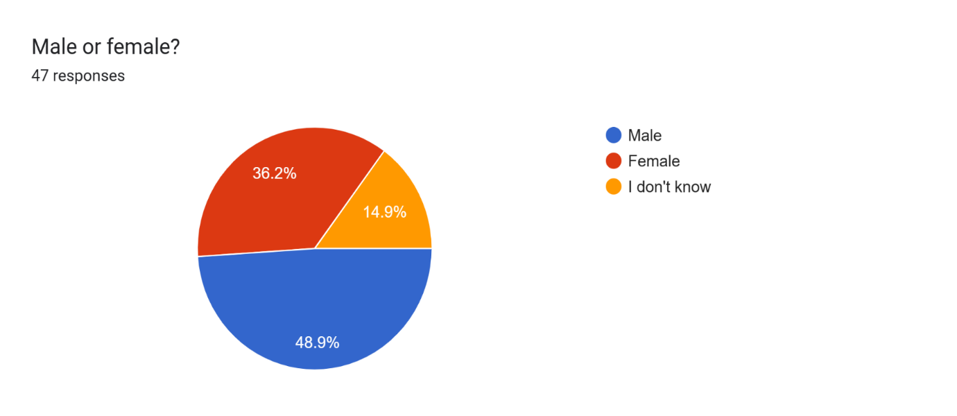
- Age at death

In the 47 responses, age at death ranged from 1 year old (1 Samoyed) to 14 years (7 Samoyeds).
The most common age at death was 12 years old (19.1%, 9 Samoyeds), followed by 13 years old and 14 years old (14.9% or 7 Samoyeds each), 11 years old (12.8%, 6 Samoyeds), and 10 years old (8.5%, 4 Samoyeds).

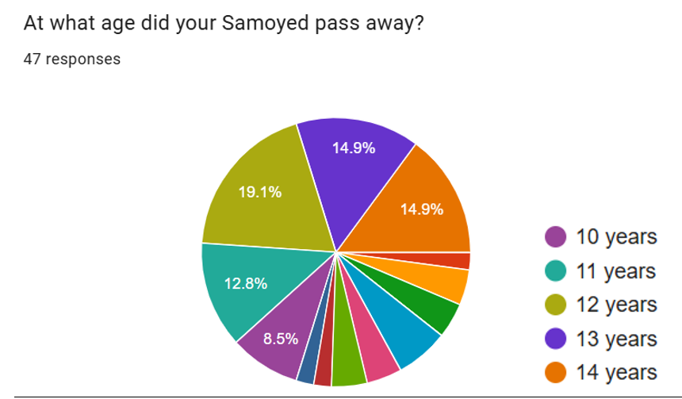

For the other ages, percentage and corresponding number of Samoyeds who died at that age are as follows:
2 years (4.3%, 2 Samoyeds)
3 years (4.3%, 2 Samoyeds)
4 years (0)
5 years (6.4%, 3 Samoyeds)
6 years (4.3%, 2 Samoyeds)
7 years (4.3%, 2 Samoyeds)
8 years (2.1%, 1 Samoyed)
9 years (2.1%, 1 Samoyed)

Overall the sample was fairly long lived, with mortality rates only rising significantly from 11 years old.
- Causes of death

Cancer was overwhelmingly the largest cause of death in this sample, accounting for 20 of the 47 deaths reported (42.6%). The most common cancers were mammary cancer (5 bitches), followed by spleen cancer (3) and liver (2) cancer, nasal cancer (2), anal cancers (2), mouth cancer (1), skin cancer (1), adenocarcinoma (1), and unknown (1).

The range of ages at death from cancer was 5 years old (stomach cancer) to 12 years old (spleen cancer).
Six dogs (12.8% of the sample, 3 males and 3 females) died with diabetes. Owners reported co-morbidities (health conditions that came with diabetes) such as cataracts and resulting vision loss, neurological disease, kidney disease, and overall decline in quality of life. Age at death from diabetes ranged from 5 years to 14 years. The 3 affected females died at 5, 8, and 12 years while the males were relatively longer lived, dying at 12, 13, and 14 years.

Five dogs (10.6%, all males) died of kidney disease/failure. Of note, two of these males (one imported and one bred in the UK from import parents) died at 2 years old with deformed/missing kidney/s characteristic of the renal dysplasia that has also been reported in young male Samoyeds bred from UK lines. The remaining three were over the age of 10 years.

Three or more died of musculoskeletal conditions (one American owner filled out a single form for “several” of her rescues, all of whom died of arthritis as old dogs). All dogs dying of this cause were a good age; one an 11 year old bitch who died from spinal degeneration and the other a 14 year old dog with arthritis, muscular degeneration, and canine cognitive dysfunction (doggy dementia).

Three deaths from seizures or epilepsy were reported. Tragically, the youngest was just a year old; her owner reported that her brain and eyes had not developed correctly, which led to uncontrollable fitting. The second was a 3 year-old male whose death from epilepsy is described by the owner as Lepto 4 vaccine-induced. The third was a 11 year old male who died with brain seizure.

Two Samoyeds died from pancreatitis. Two died of bloat and one died of complications following surgery to remove a foreign object the dog had eaten. One died from an insulinoma and multiple organ failure: an insulinoma is a generally benign tumour that produces insulin and causes the opposite of diabetes, i.e., very low blood sugar levels.

Only three dogs died of old age.

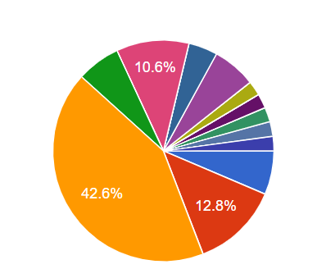.
SEIZURES/EPILEPSY
PANCREATITIS
JOINT/MSK
CANCER
KIDNEY FAILURE
DIABETES
OLD AGE

The most common causes of death

Other details:
About 81% of the dogs died by euthanasia, and none of the causes of death had been verified by full post-mortem.

Conclusions
Some of the trends observed here mirror those reported in the last Annual Health Report (2015):
Cancer was the most frequent cause of death. The range of ages at death from cancer was 5 to 14 years, with the youngest dying of stomach cancer.
Mammary cancer was the most common form. Risk increases with age among entire bitches, and spaying is still advised to lower risk. The BVA have however recently tempered their spay/neuter recommendations in light of evidence indicating that juvenile spay/neuter comes with pitfalls of its own. According to the latest BVA guidelines, the optimal age to spay is a context-based decision, made by owner and veterinarian, balancing the various risks and benefits involved. It is advisable that owners check their bitches’ abdomen area (and indeed other areas) regularly for lumps or bumps.

Spleen cancer is still the second most common type of cancer; this is likely a condition called haemangiosarcoma. Several breeds have a predisposition to this condition, which suggests a genetic component in these breeds. This may also be the case with Samoyeds—however, verification would require analysis of many more dogs as well as pedigree data to examine whether the conditions clusters in families.

Diabetes was the second most frequent cause of death, and whilst in many cases diabetes is manageable with medication, it has a significant impact on health and overall quality of life, causing blindness, weakness, and overall debility. Bitches seemed to be affected at a younger age than males; this may be related to intact status as repeated progesterone cycling during seasons increases diabetes risk. However, as the forms do not currently ask spay/neuter status, it could not be verified whether the affected bitches were spayed or not.

Kidney disease, the 3rd most frequent cause of death, is still being reported among young males in whom the kidneys have not developed correctly; in this Report, the two young affected dogs were either imported or descended from imports. In her 2015 Report (a copy is available on the Downloads page of the Samoyed Breed Council website), Dr. Serena Brownlie-Sykes explains that “in the UK there have been occasional reports of juvenile nephropathy in Samoyeds but they have not been proven to be the same condition as…” (the X-linked hereditary nephritis for which a DNA test is now available).
Breeders must therefore consider that in addition to the kidney condition we can test for with the Laboklin SHN DNA test, Samoyeds are likely affected by other kidney development problems and resulting kidney disease which cannot currently be tested for with a DNA test.
Dr. Brownlie-Sykes adds “This leads me to the conclusion that all Samoyed bitches should have a urine test prior to breeding and any which have excessive amounts of protein in their urine should not be bred from until this has been investigated.”

Pancreatitis accounted for two deaths, one of them a 3 year old bitch. In these two cases, no other “co-illnesses” were reported, but the condition is often associated with diabetes. Pancreatitis can be triggered by fatty foods, so it is advised to keep dogs lean and avoid feeding high-fat foods.

There are also some differences from the 2015 Health Report, which reports 3 deaths from whelping complications (2 with hydrops). No deaths from this cause were reported for the current sample. However, in the current Report, 3 Samoyeds died from seizures or epilepsy – a cause that was not mentioned in 2015.

A heartfelt thank you to the Samoyed owners who trusted us with the information in this report. We are very sorry for your loss.
- Notification of Illness Forms

Only 4 notification of illness forms were received between 2020 and April 2026. All 4 were for bitches who were spayed; at least one was spayed as treatment.
Two bitches were diagnosed with cancer: one was 3 years old with liposarcoma of the pelvis, treated by hemipelvectomy and chemotherapy; the other with a very rare form of ovarian cancer, at just one year old, treated by removal of all reproductive organs.
The other two bitches were both diagnosed with glaucoma, one at 7 years and the other at just 4 years old. Both were treated by removal of the affected eye/s.

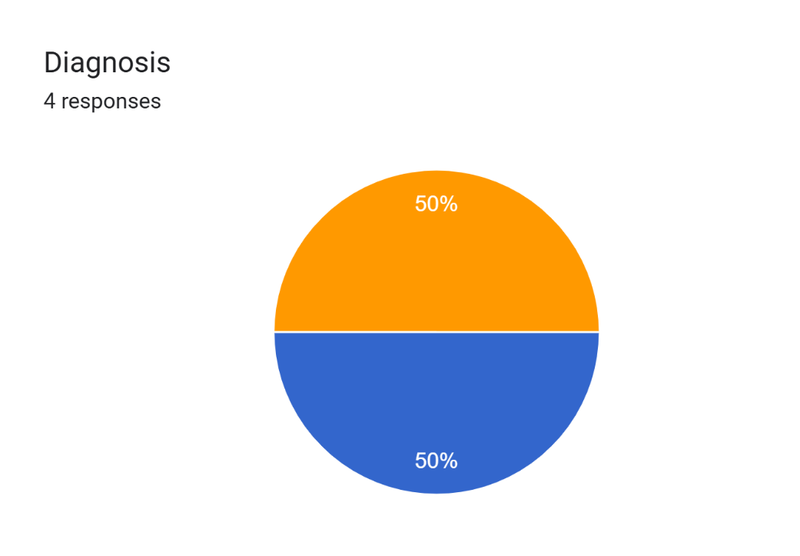
GLAUCOMA
DIABETES

Heartfelt thanks to the Samoyed owners who trusted us with the information in this report; we hope their dogs are doing well.

